

Solent University

Web Application Development

Software Product

**QHO540**

**Alessandra Francesca Salanitri**

Word count:

Table of Contents

Introduction 3

Project Requirements: 3

The database structure: 4

Back-end REST API Development 6

The Client: 9

RESTer Testing: 12

Front-end 14

Result: 37

Running the project in a standard Node 14x environment using a Linux machine. 45

References 48

# Introduction

This project comprehends the development of the “Place to Stay” site.

Place To Stay allows users to look up information on places they might want to stay while away from home, such as hotels, bed and breakfasts, villas, and hostels.

This project is built with Node.js and Express for the backend, SQLite for the database, and React for the front end.

This report details the development process, errors encountered, and solutions implemented.

# Project Requirements:

1. Look up all accommodations in a given location.
2. Look up all accommodations of a given type in a given location.
3. Book a place of accommodation for a given number of people, on a given date.
4. A confirmed booking record should be added to the acc_bookings table and reduce the availability in the acc_dates table.
5. Build a front-end page, with a user-friendly interface.
6. Create a Book button for each accommodation.
7. Adding error-checking handling code to display for the user with a user-friendly, non-technical message.
8. Using Leaflet, display an OpenStreetMap where the results are displayed as markers on the map.

## When the user clicks on the marker in the map, the accommodation name and description appear as a popup.

1. Implement a session-based login system.
2. A user should be able to log in from the main index page.
3. If a user logs in successfully, a message should be displayed within a <div> on the index page.
4. The user must be logged in to book an accommodation, an appropriate message is sent if they are not.
5. If there is no availability for the date or the number of people the user wants to book for, an appropriate message is returned to the user {e.g. You cannot book for a past date or, sorry, there is not enough availability}
6. Fetch API is used to implement the Front end.
7. The project is developed using middleware, controllers, and routes.
8. Add a file-upload facility to upload a photo of the accommodation.

Only logged-in users can upload an image.

1. Mock-payment system to confirm the booking.

# The database structure:

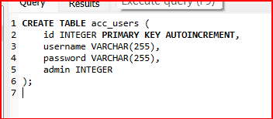

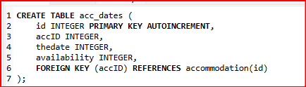

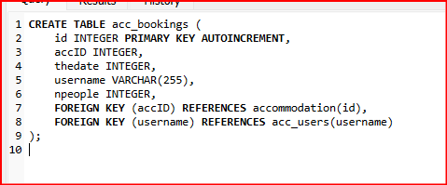

Each table has an “id” column as the primary key with autoincrement to generate automatically unique identifiers for each new record.

In **“acc_dates**” and “**acc_bookings**” tables, “**accID**” references the id from the “**accommodation”** table for relational integrity, “**acc_bookings**” includes a foreign key reference to “**username**” from the “**acc_users**” table.

Successively some dummy data was inserted into the **“accommodation**” and “**acc_users**” tables to allow testing:  
  
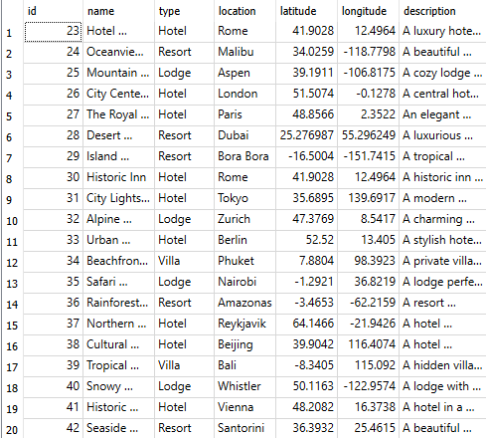

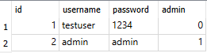

# Back-end Development

The backend is initialized with Node.js and Express, with the following setup:

**“cd server”** –

**“npm init -y”** –

**“npm install express sqlite3 body-parser passport passport-local express-session”.**

Installing the “cors” package with the command:  
“**npm install cors**”.

* database.js

The below code sets up a connection to the SQLite database file “placeToStay.db”, handles connection errors, and exports the database connection for use in other parts of the application.

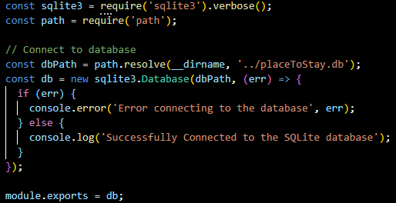

* index.js – server

The code below sets up the environment for a Node.js web application.

It imports modules for web server functionality (express), parsing request bodies (body-parser), user authentication (passport and passport-local), session management (express-session), SQLite databases (sqlite3), handling file paths (path), and enabling CORS (cors). - Cors stands for Cross-Origin Resource Sharing, is a mechanism that allows a way for web pages to access API or assets running on a different restricted domain. (2020) - It initializes an Express application and establishes a connection to the database “placeToStay.db”. Then, it sets middleware and routes for the application.

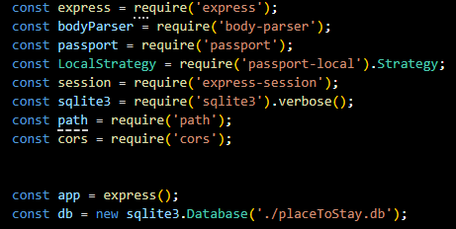

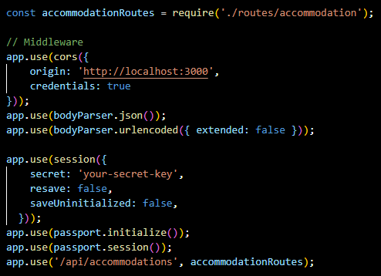

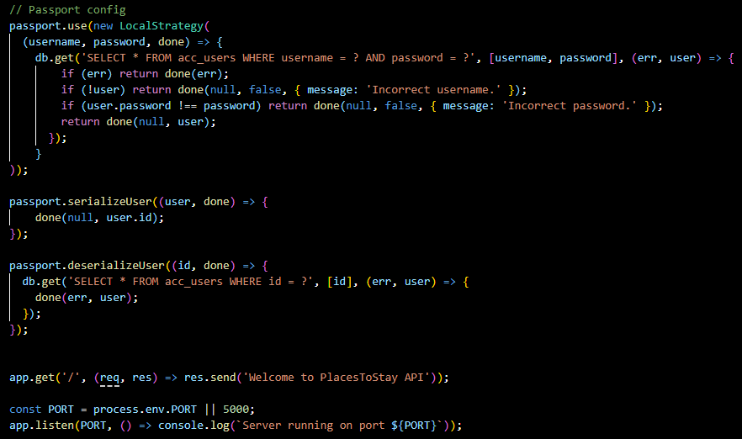

* accommodation.js

The code below checks if a user is authenticated. If yes, it proceeds to the next middleware or route handler otherwise, it responds with an Unauthorized status.

It then defines a route to get “accommodations by location”, or “accommodations by type and location”, and uses the location parameter from the URL to query the database for the requests.

It responds with the data requested or an error message if something goes wrong.

It also defines a POST route for booking accommodation, with authentication required.

Checks for necessary fields and queries the database to check availability for the accommodation ID and date. If available, it inserts a new booking into the database and updates the availability. Responds with success or simple error messages based on the operation outcomes.

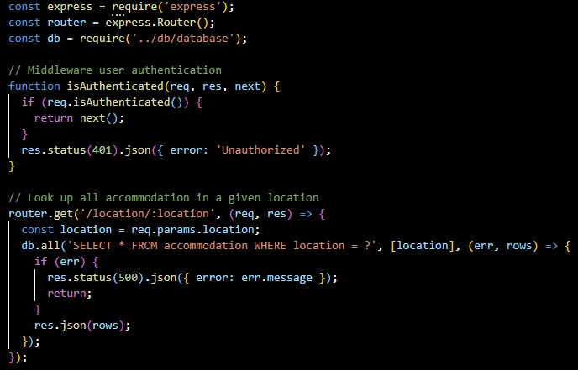

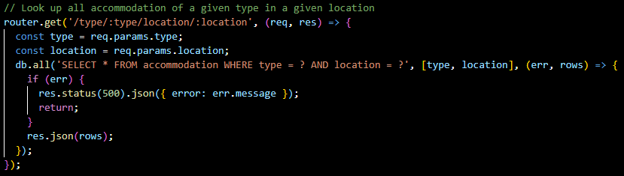

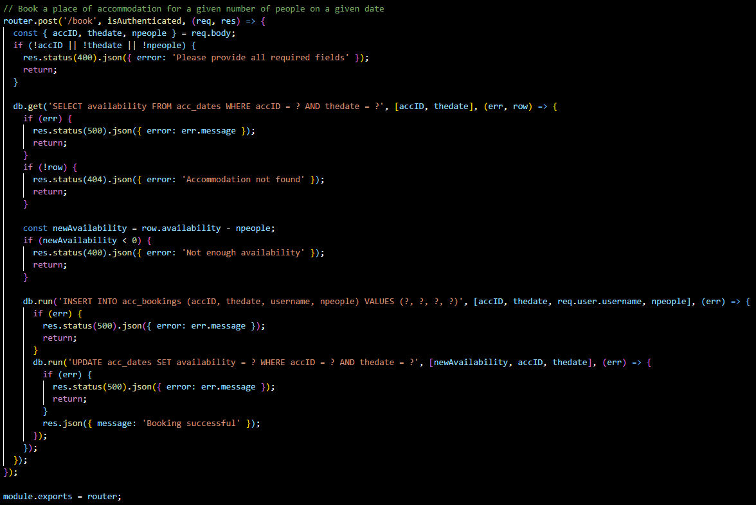

# The Client:

Navigating to the Client side,

**“npx create-react-app places-to-stay” –**

**“cd places-to-stay”.**

**“npm install leaflet react-leaflet”.**

In the **“src”** folder, the “**Search.js**”, and **“AccommodationList.js”** components have been created, while the main **“App.js”** has been implemented to manage the overall application state and render components based on the user interaction.

* Search.js

The Search component provides an input for users to enter a location and a button to search. When the button is clicked, it fetches accommodations for the entered location from the server and passes this data to the parent component.

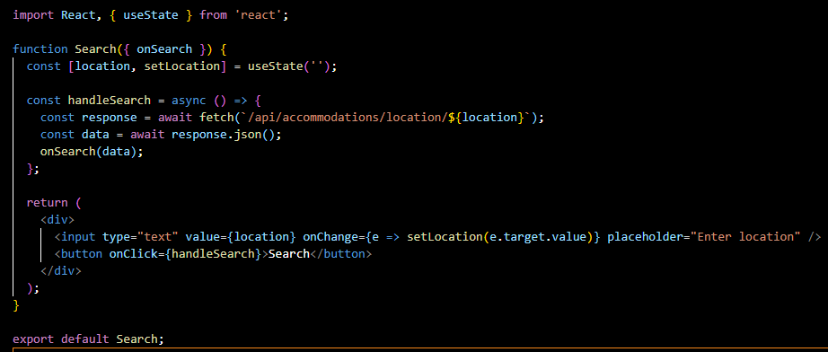

* AccommodationList.js

AccommodationList, displays a list of accommodations and provides a booking button for each one of them. It uses the map to iterate over accommodations and render each as an item list, displaying the name and type of each accommodation. Each item of the list includes a "Book" button that calls the onBook function with the accommodation's ID when clicked.

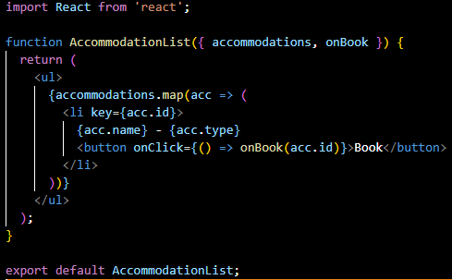

* App.js

App.js manages the state and interactions for searching and booking accommodations:

Uses “useState” to manage the accommodations state. The “handleSearch” updates the accommodations state with the search results. The “handleBook” sends a POST request to book an accommodation with a hardcoded date and number of people and displays the response message in an alert. It then renders the results with “handleSearch" passed as propriety, and the “AccommodationList” component with the current accommodations and “handleBook” passed as propriety.

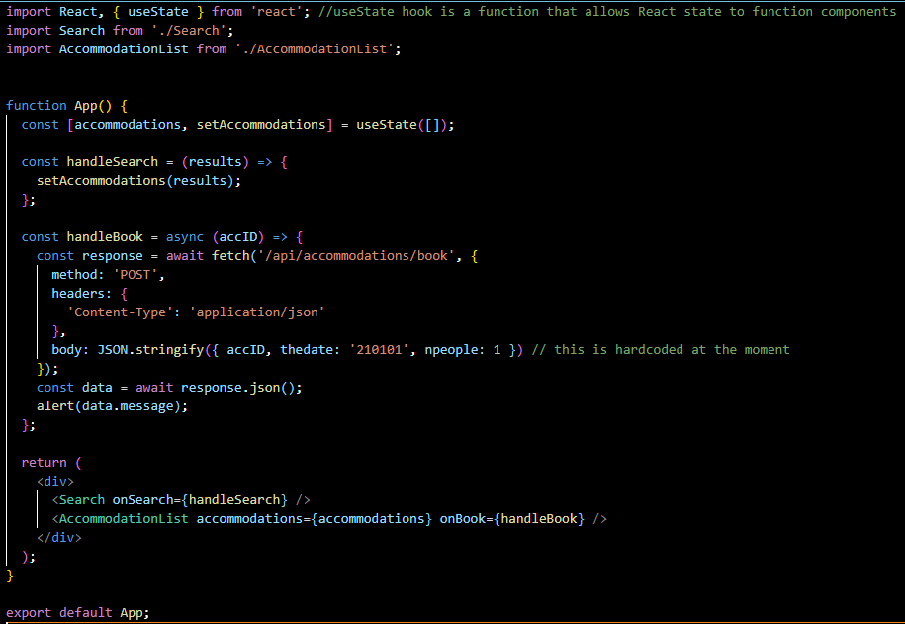

# RESTer Testing:

To ensure the functionality of the server, a test is conducted with RESTer.

To start the application:

Run the command **“node index.js”** in **“Place To Stay\server”**   
  


* Test the search by location feature:

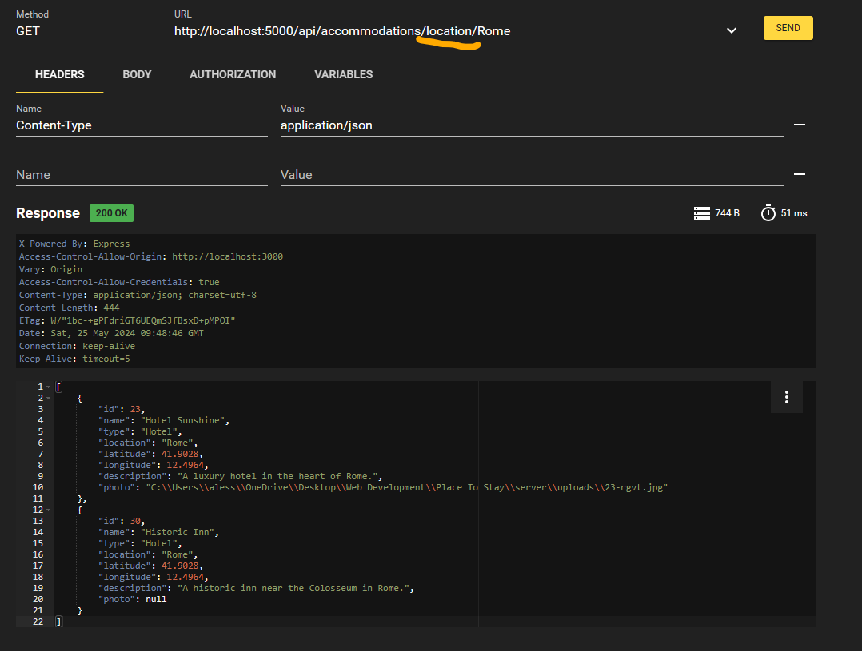

* Test the search by location and type (e.g. hotel, resort, villa) feature:

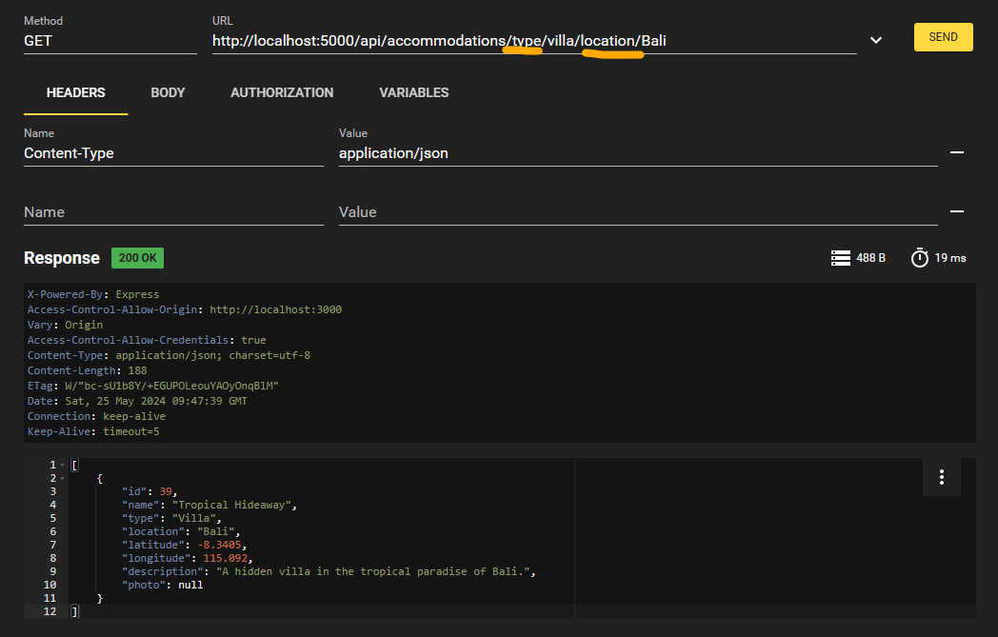

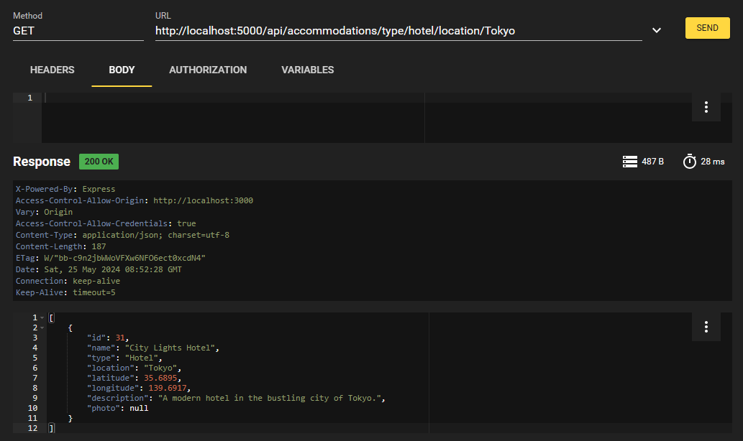

# Front-end

The client interface will now be implemented with the use of React.

The below-displayed component allows users to enter a location and search for accommodations by clicking the Search button. The results are fetched from an API based on the entered location. Any errors during the fetch process are logged into the console to display if something goes wrong.

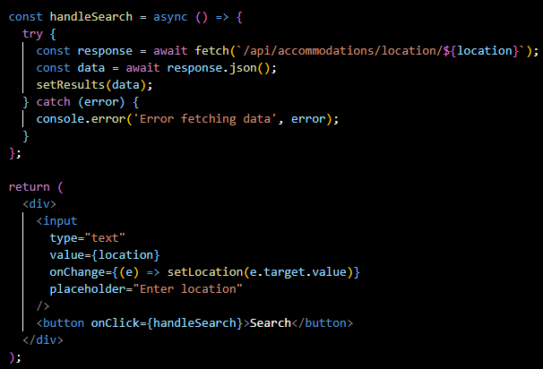

The below-displayed component uses react-leaflet to display an interactive map centered at a specific hardcoded location. It also displays markers indicating the positions of different accommodations. Each marker includes a popup displaying the accommodation's name and description.

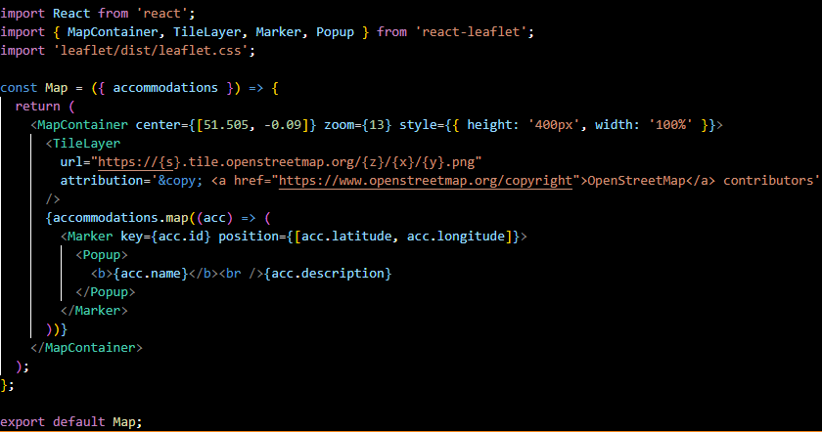

The below-displayed function sends a POST request to book an accommodation with the provided ID, handling both successful and failed booking attempts by displaying appropriate messages. It uses hardcoded values for the date and number of people for demonstration purposes.

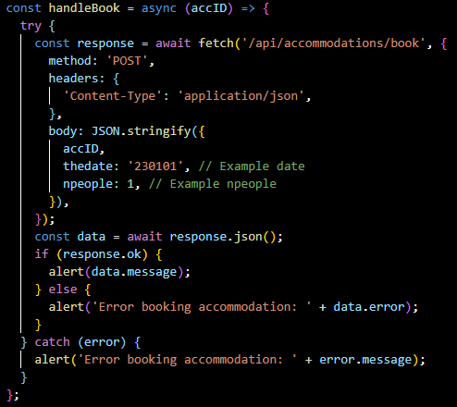

The map is then added to “App.js”





* Auth.js

The below-displayed code sets up routes for logging in and out of the application and for retrieving the current user's information. It uses Passport for authentication and manages user sessions, providing relative results based on the authentication status.

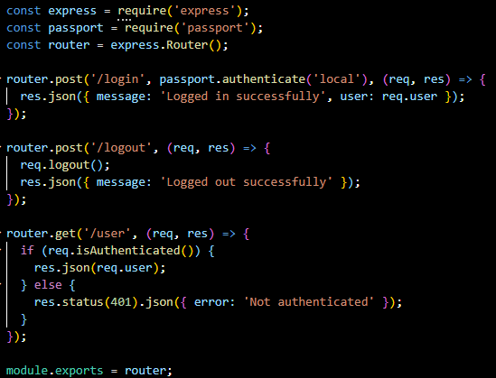





The Login component, shown below, provides fields for input username and password, and a button to log in. It sends the login details to the server, handles the response, and updates the parent component with the user data if the login is successful.

It also displays alert messages for success or error.

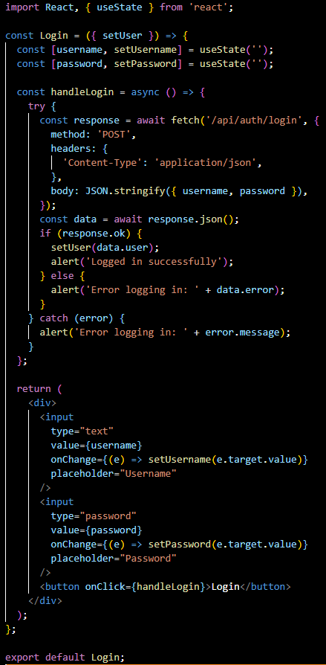





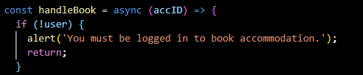



The below-displayed AccommodationList component allows users to select a date and the number of people for each accommodation and provides a button to book the selected accommodation. The state management for the date and number of people ensures that the selected values are passed correctly to the booking function. For the date selection “react-datepicker” has been installed with the command:

**“npm install react-datepicker”.**

**“npm install date-fns”**

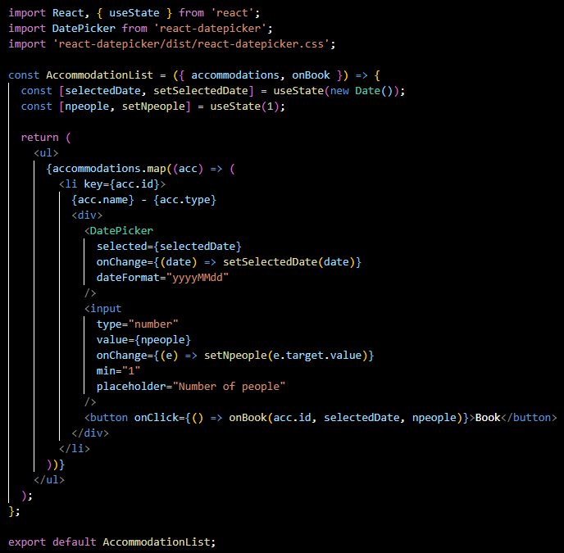

Successively, the “App.js” has been updated to pass the selected date and the number of people from the user to the booking handler.

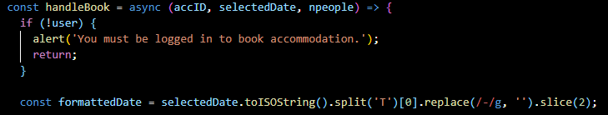

The code below handles photo upload for accommodation. For file uploads multer installation:  
“**npm install multer**”.

It handles the booking of an accommodation, validates a credit card number, and displays a list of accommodations with booking and photo upload features.





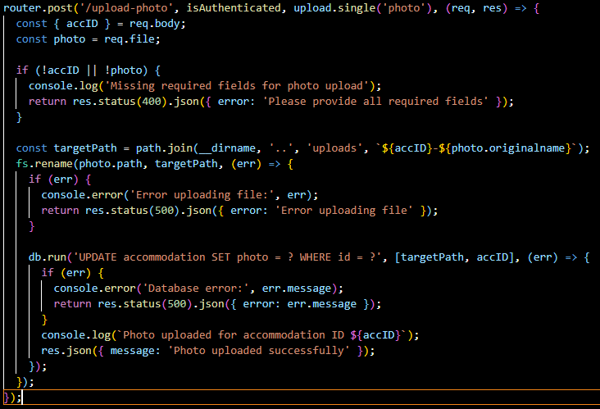

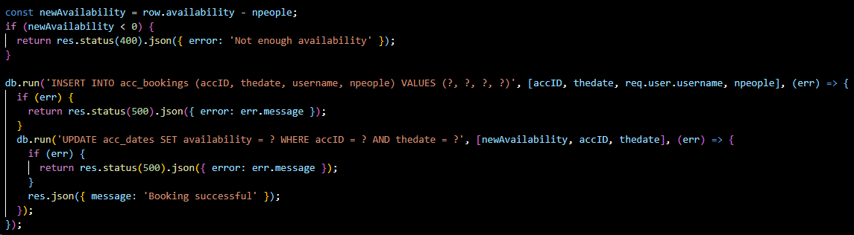

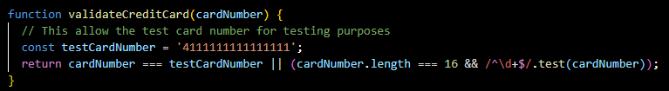

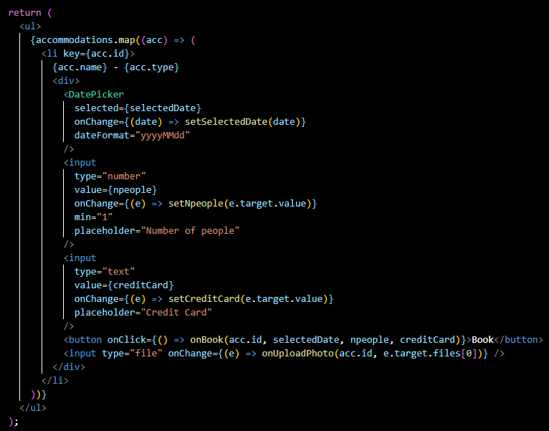

The below-displayed function uploads a photo for the selected accommodation by sending a POST request with the photo file and accommodation ID as form data. It handles the server response by displaying success or error messages.

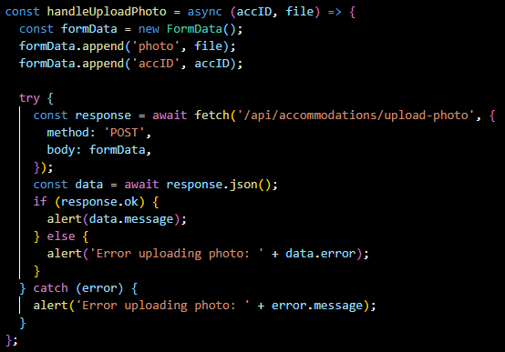

To test the functionality of the user authentication system and the so-far-built system, the client side is tested.

Run the command **“npm start”** in “**Place To Stay\client\places-to-stay”**



Tested using username: admin – password: admin, the login works successfully.

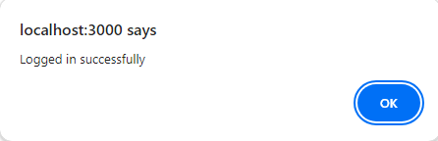

To display the Logged-in User’s Status, and add the logout feature, the “**App.js**” is updated:

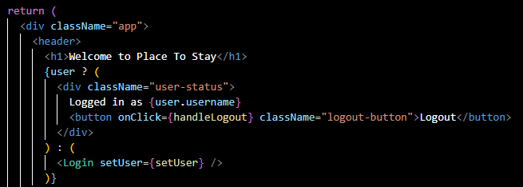

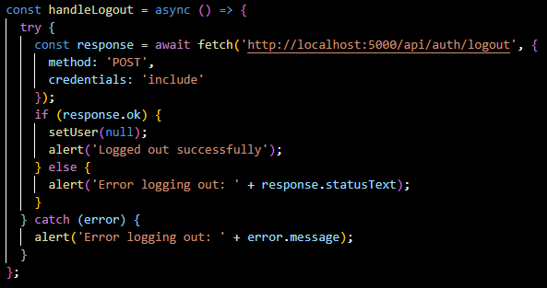

For the Logout button, the “**auth.js**” route has been modified:

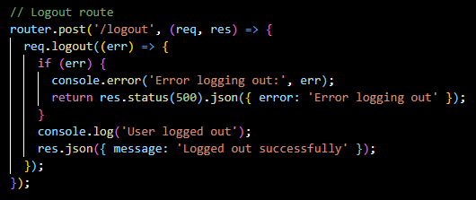

And Update **“Search.js”** and “**AccomodationList.js**” to handle the search and booking functionality:

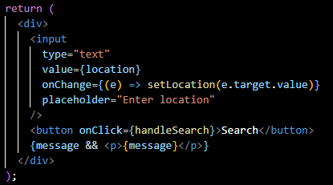



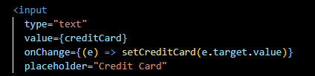



After initial testing, when searching for a location, the result was not displaying the marker on the map, hence the “**Map.js**” code was modified to set up a custom marker icon for Leaflet maps and defines a React component that updates the map view to specified coordinates without changing the zoom level. The custom icon increases the map's visual consistency using shadow images.

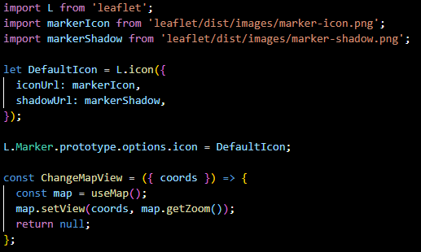

It then renders a Leaflet map with custom markers for each accommodation. It dynamically changes the map view based on the provided coordinates retrieved from each accommodation requested by the user input and uses a tile layer from OpenStreetMap.

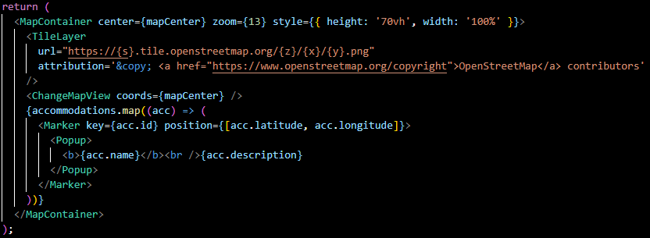

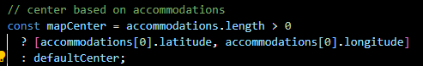

Testing functionalities:

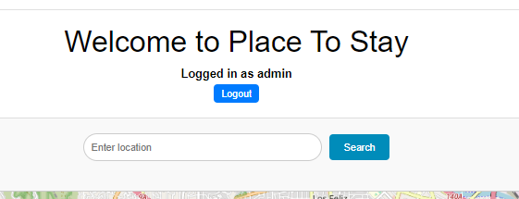

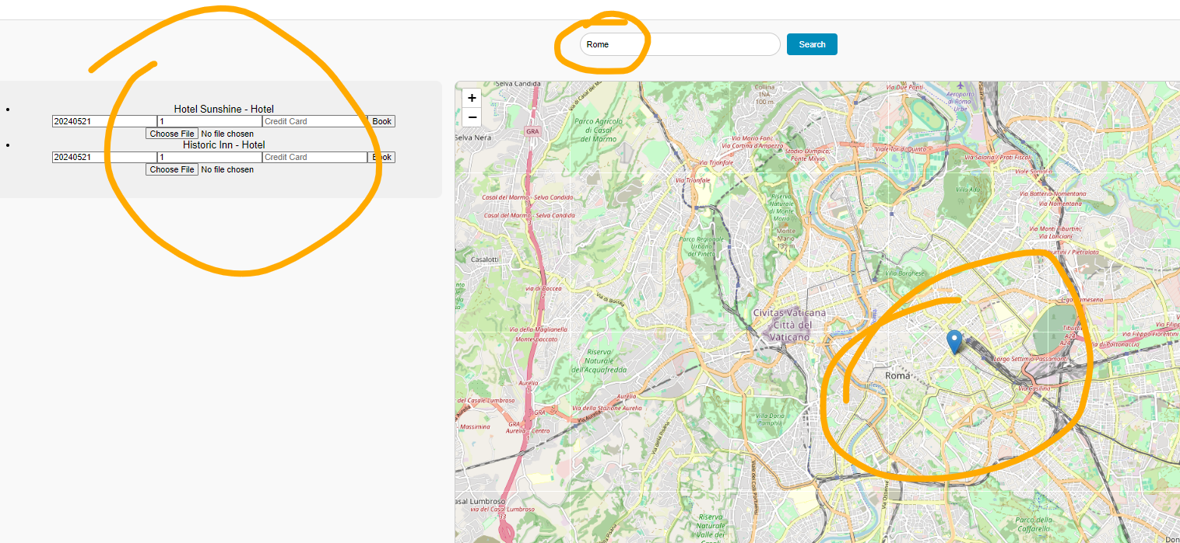

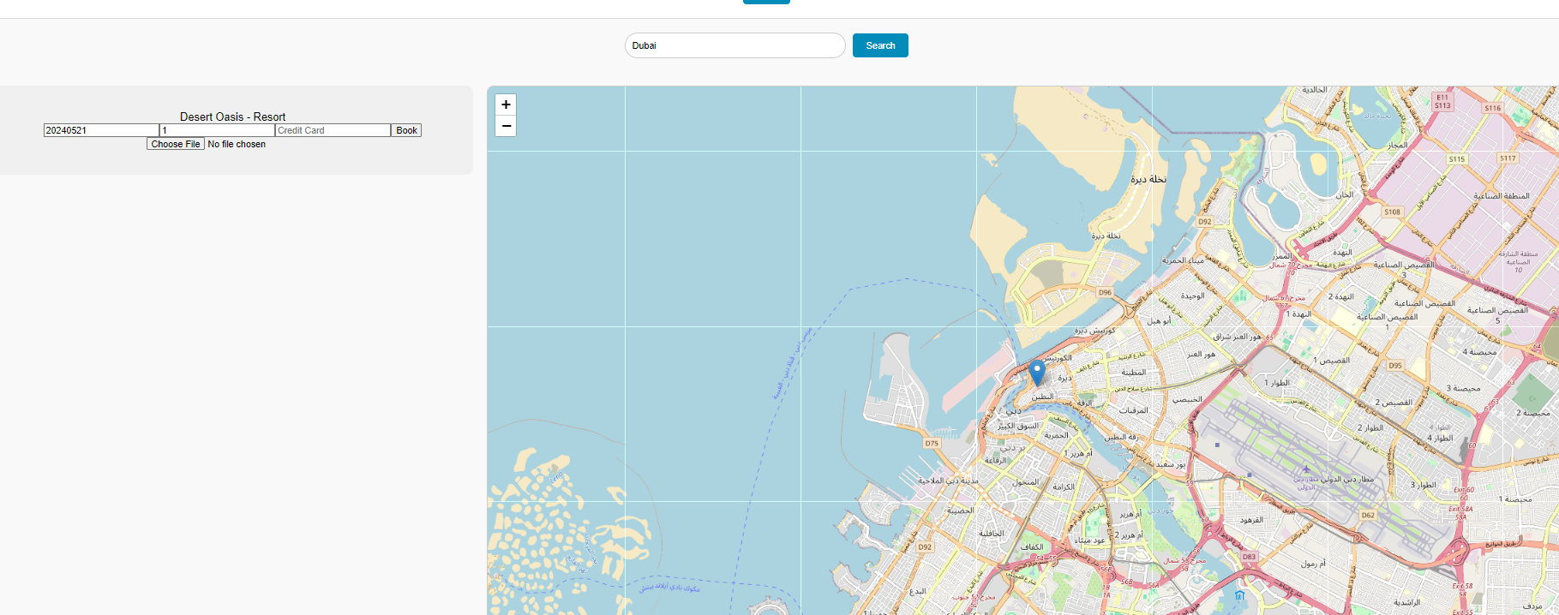

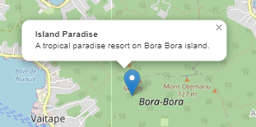

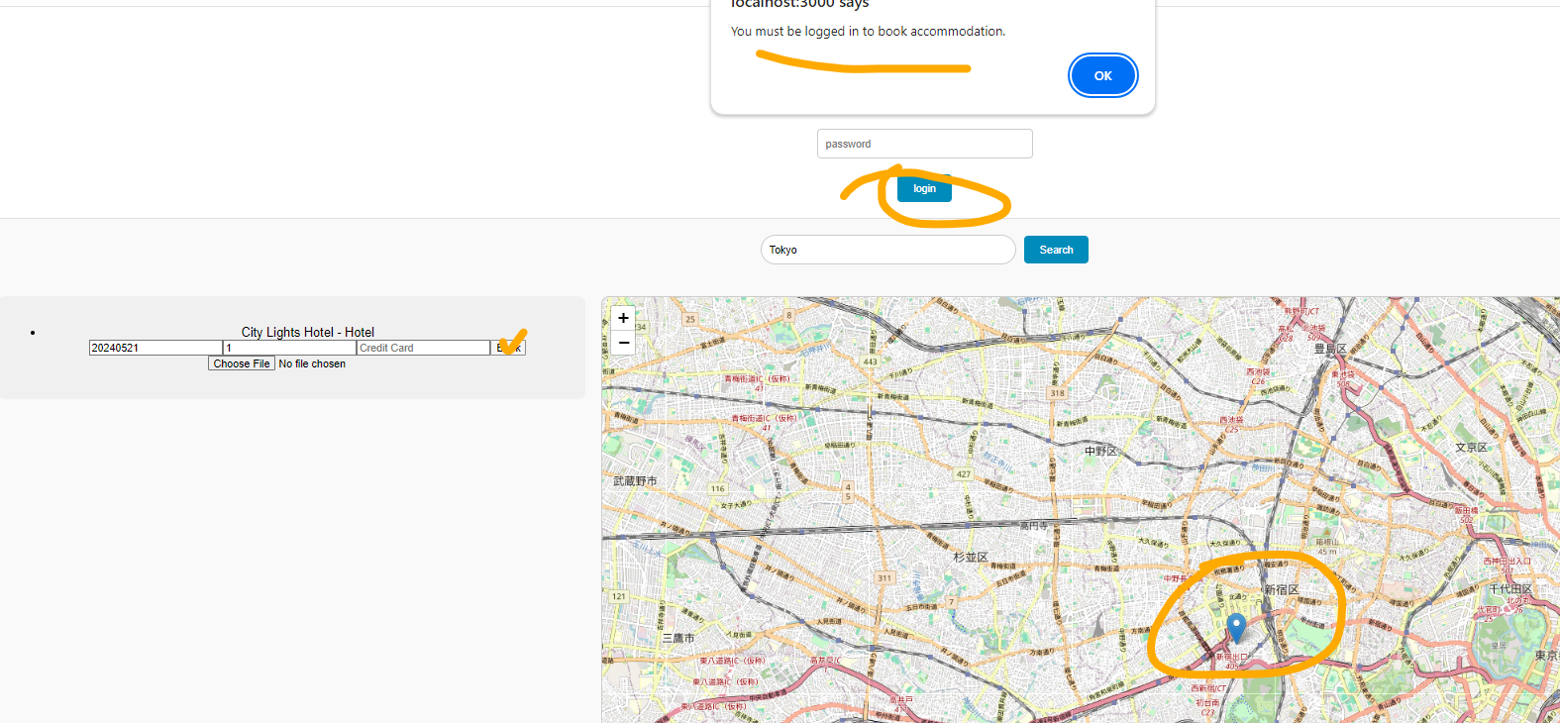

# ERROR HANDLING:

Encountered a problem with uploading images to the location:

*Error message from the website:***“Error uploading photo: Failed to upload photo”.**

*Error message from the console:*

**“User admin is authenticated”.**

**“Database error: SQLITE_ERROR: no such column: photo”**

Hence, a column “photo TEXT” has been added to the table ***accommodation*** in the database:



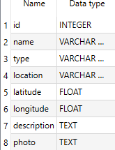

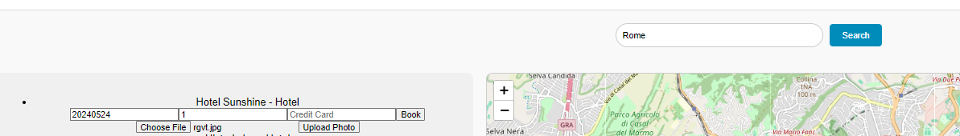

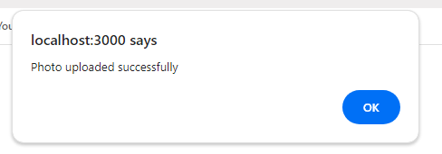

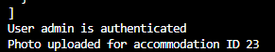



When trying to book an accommodation, the required fields are requested from the user:

Date, number of people, and credit card details.

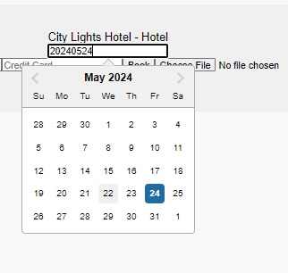 

While testing, I wasn’t able to book. The system was not able to retrieve the availability. The output received:

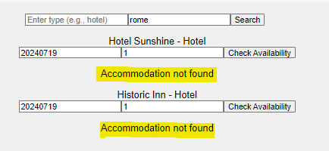

A query was run into the database to insert for each accommodation ID, 20 available spaces with a query for each one the accommodation IDs:

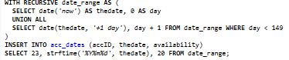

This query generates 150 dates starting from the day the query is run and inserts them into the “**acc_dates**” table, linked with all accommodations in accommodation tables referring to its accID (23 to 42), and creates availability for 20 people for each date, for the next 150 days.



From the database, the availability is correctly displayed for 20 people.  
  


After checking the availability for accID number 24, for the date: 2024/05/31 on RESTer, the system was still not able to retrieve the accommodation.

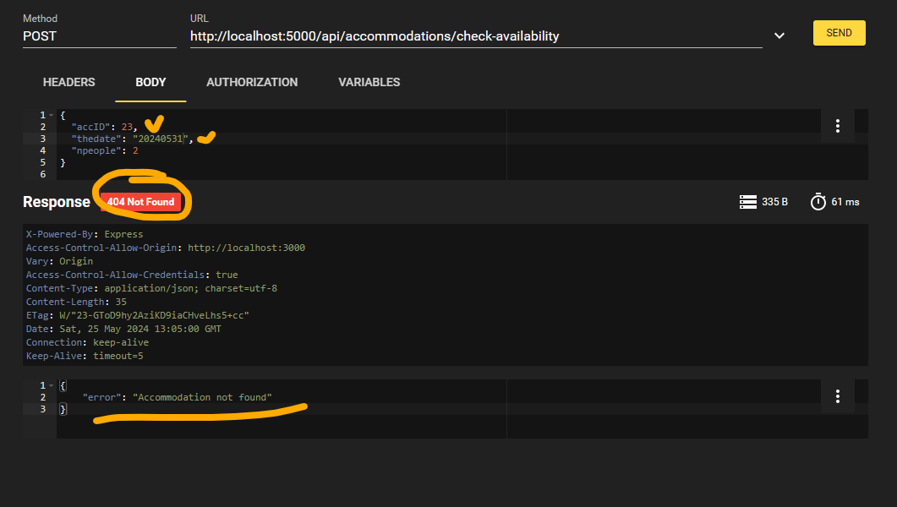

After debugging a few parts of the code, found that maybe the error might be caused by the type of “**thedate**” column. Hence, the check availability method was modified to better handle the date format:

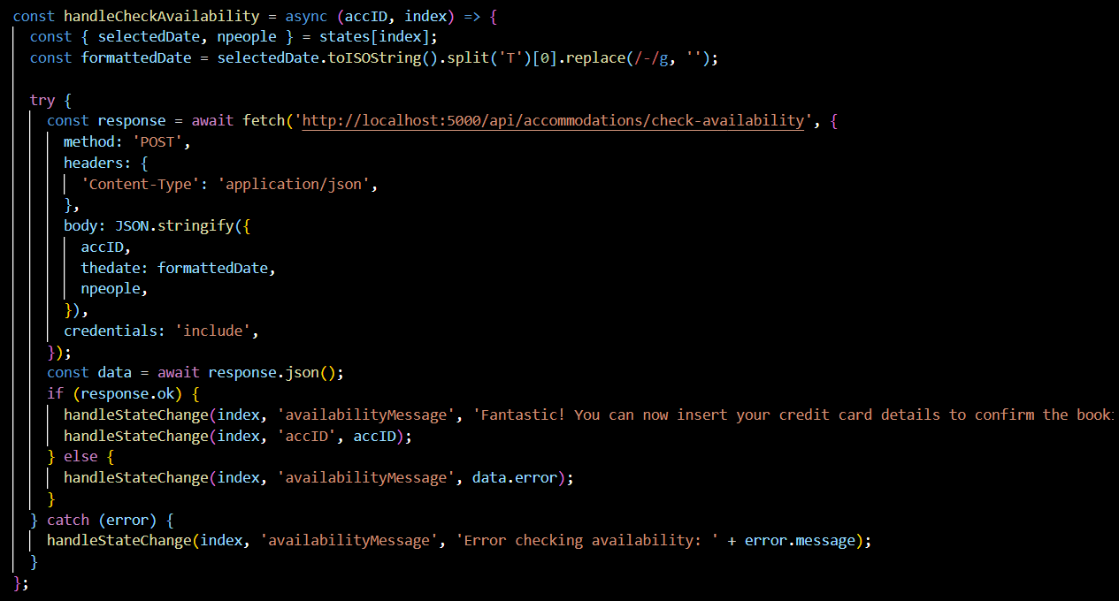

The “selectedDate.toISOString()” converts the date to a string in the ISO format:

"2024-05-29T12:34:56.789Z".

Then it splits this string at the 'T' character and takes just the date: "2024-05-29".

Then it removes all the hyphens (-) from the date string and remains: "20240529".

Logged in with RESTer:

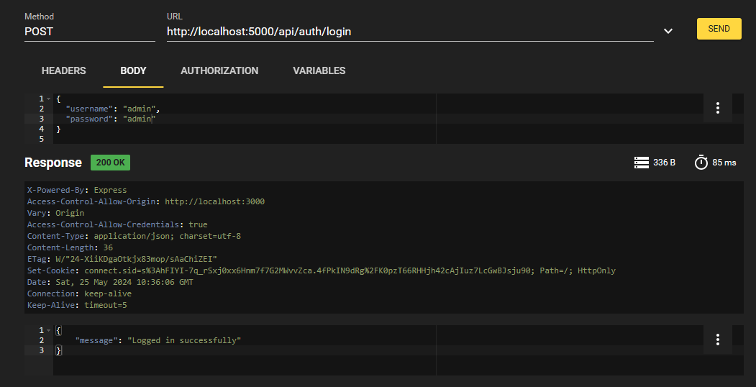

Now, in RESTer, the check-availability function returns the correct result.

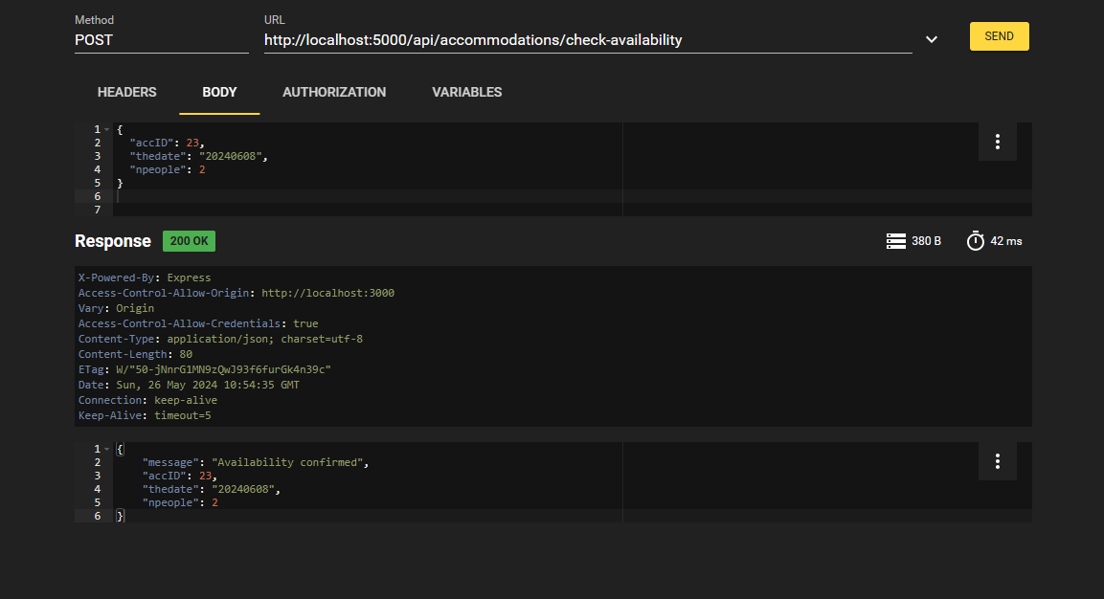

In the App, there seems to be still an error, and also realized that the input fields were affecting multiple accommodations.

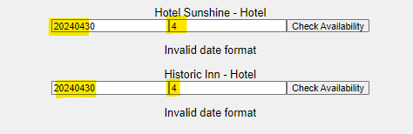

The code was hence modified to use an array of states to manage the input for each accommodation individually. This prevents the issue where user input affects multiple accommodations at the same time.

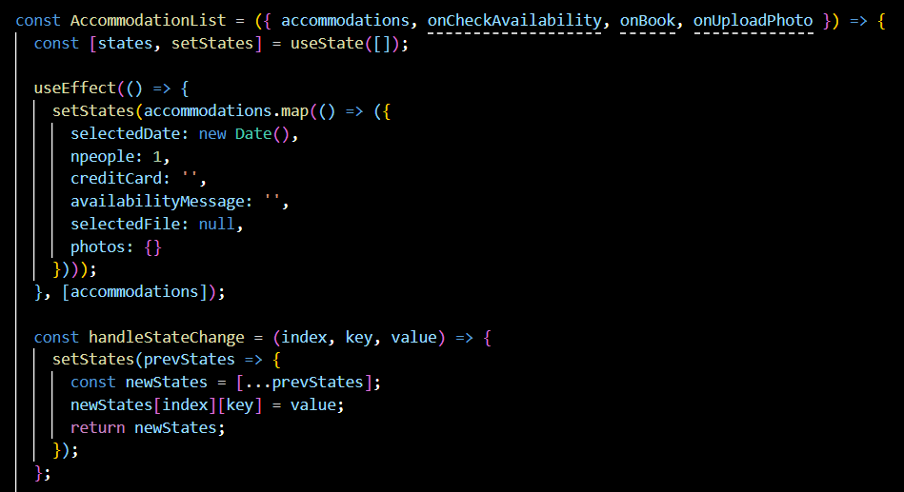

The date format issue is also handled now by formatting the date before sending it to the API. From the client side in “AccommodationList.js”:

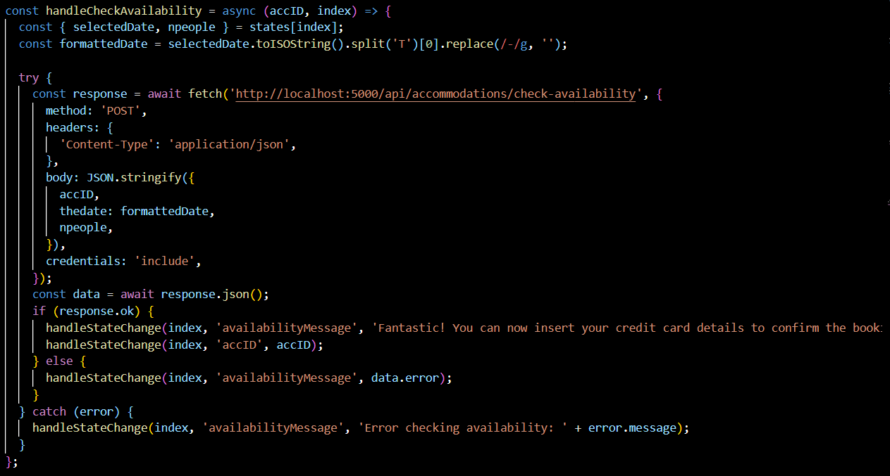

On the server side, **“accommodation.js”,** handles checking the availability of accommodation by validating the provided date format and ensuring the booking date is not in the past. It logs relevant information and returns user-friendly error messages if the date is invalid or in the past.

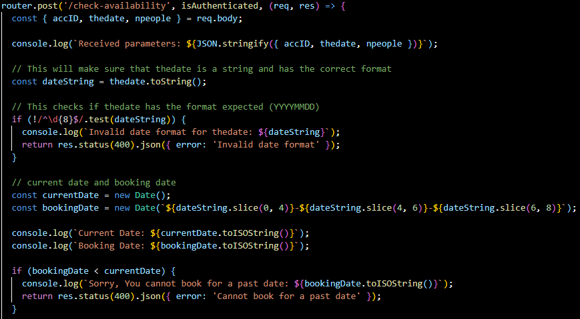

Now the input targets only the accommodation chosen by the user, the availability returns the correct result, the marker in the app appears in the right location, the pop-up with the hotel name is shown, and an image can be uploaded in any location. The image will successively be displayed as that accommodation’s image. The booking confirmation is fully functional.

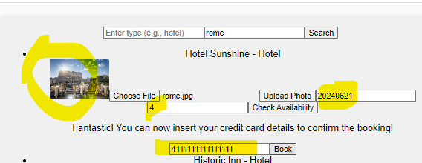

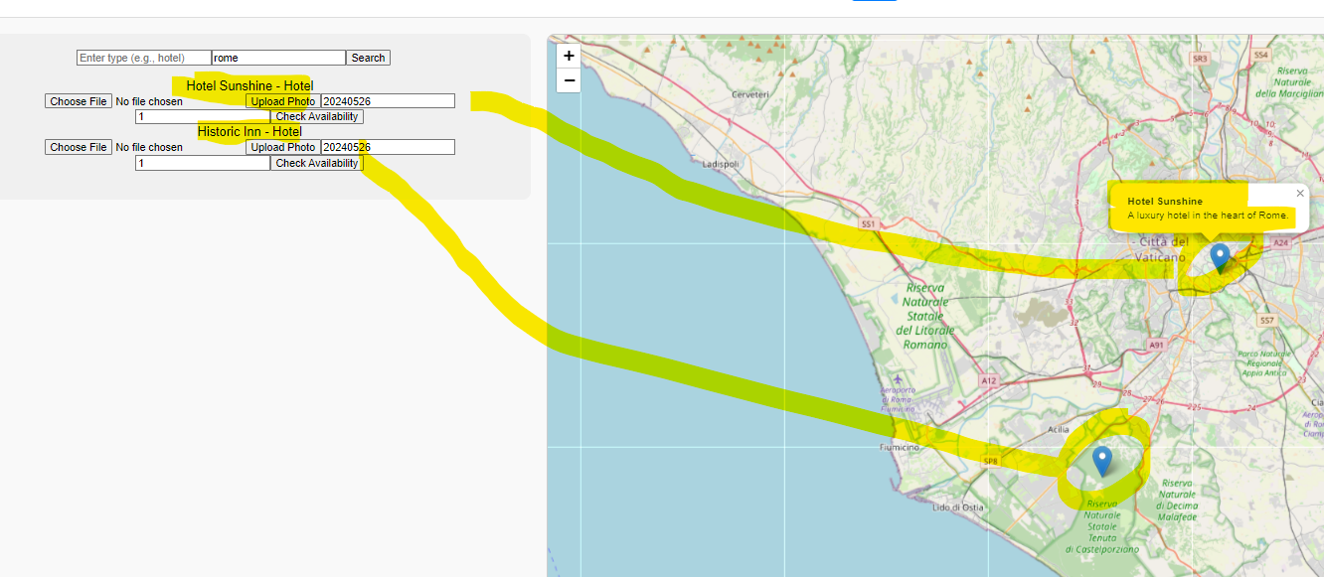

Initially, for testing purposes, the remaining availability is displayed on both the server and client sides, successively will only be displayed on the backend.

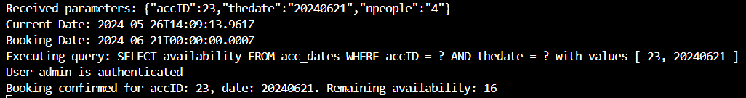

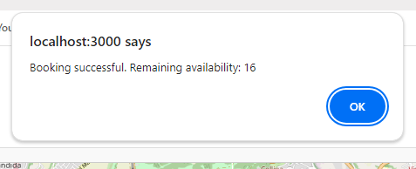

# Result:

* Main page

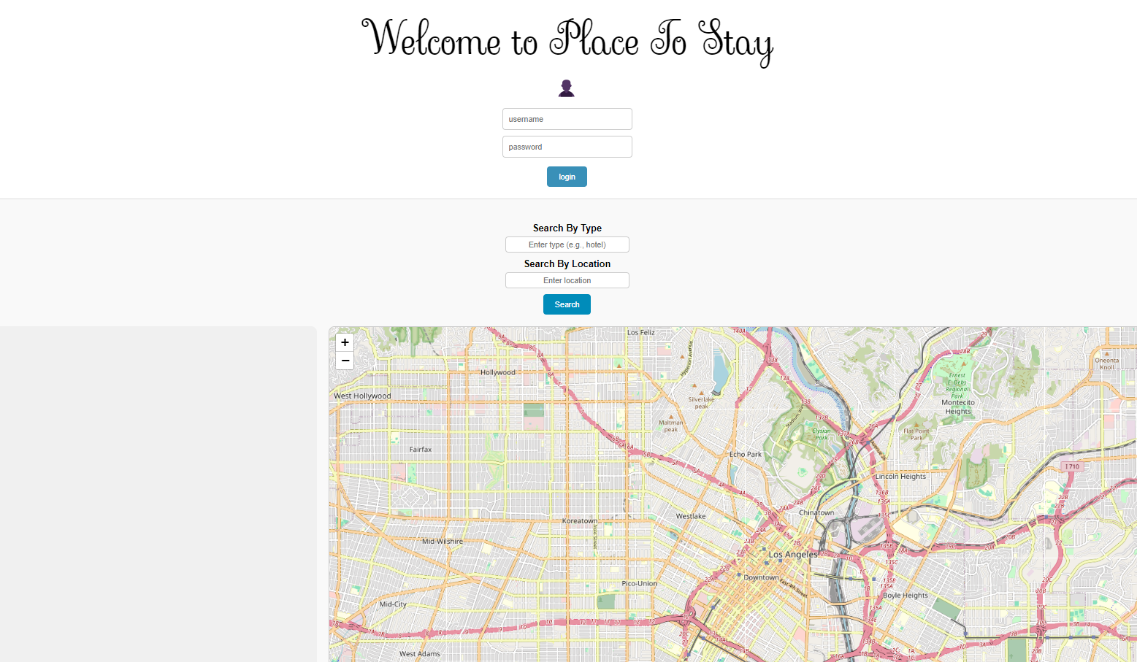

* Trying to log in without credentials to ensure that a friendly message is displayed and the app does not crash.

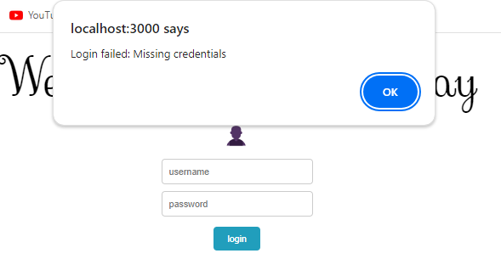

* Trying to insert inexistent or wrong credentials.

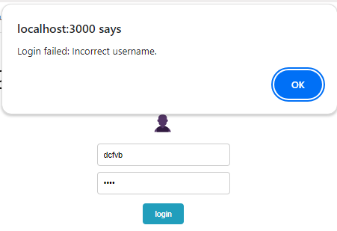

* Logging in with testing credentials {username: admin, password: admin}

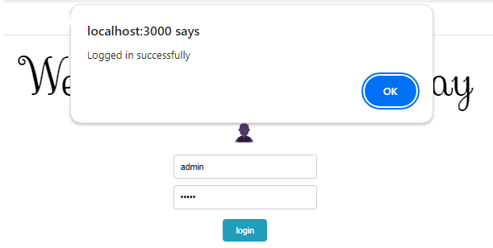

* Display the name of the logged-in user.



* Searching for a type of location not specifying where, or a location that does not exist in the DB.
* Friendly error messages.

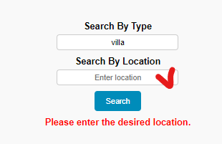

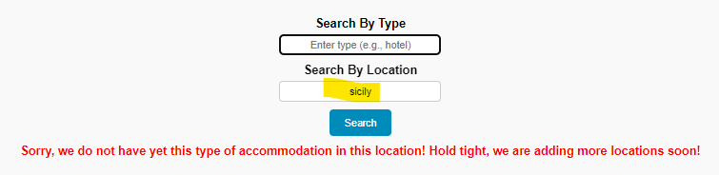

* Searching “Rome” in the location field. Results are displayed with the markers on the map, and fully on the left-hand side of the page. If the user clicks on the marker, the accommodation name and accommodation descriptions are illustrated.

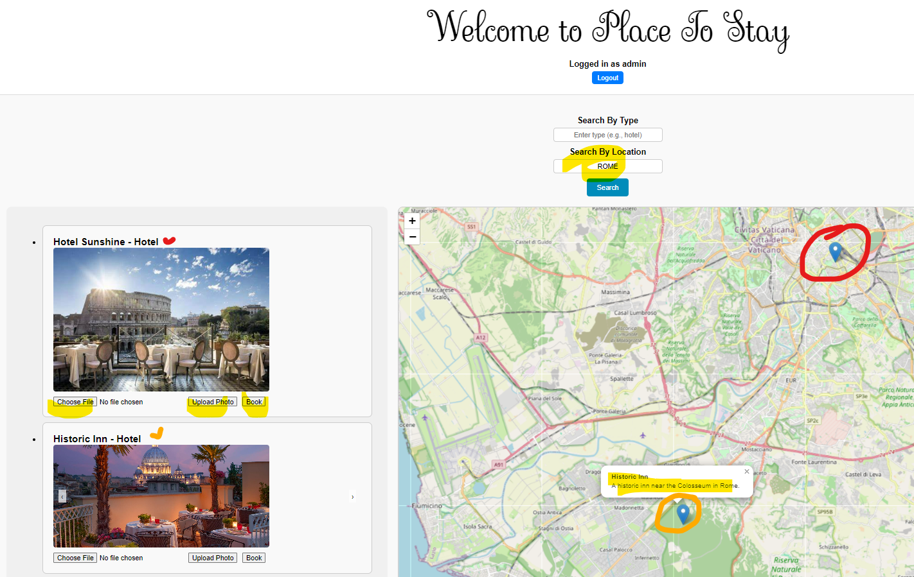

* The user can click on choose file, choose an image on his device, and upload a photo.

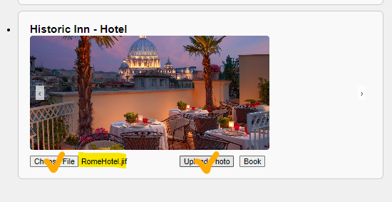

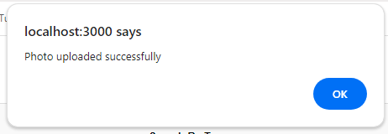

* If the accommodation has more than one image, the user can click the arrow to visualize the other images.

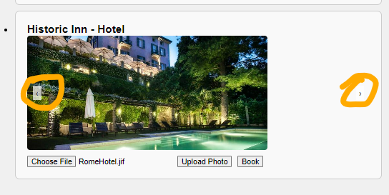

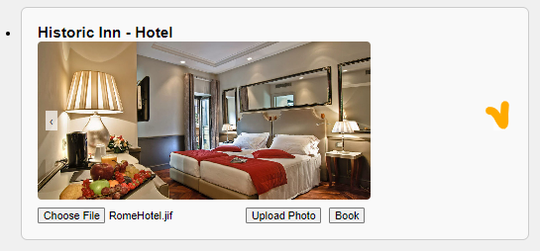

* If the user clicks on the “book” button, in a specific accommodation, the user is prompted to choose the date and input the number of people to book for.
* Trying to book for a past date (14 May 2024)

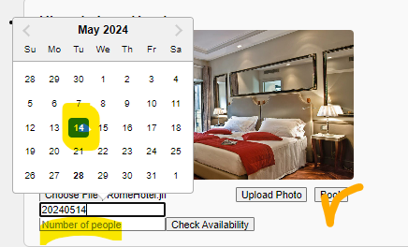

* The app displays a user-friendly message: Cannot book for a past date.

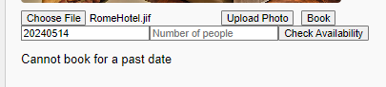

* Trying to book for 50 people.
* The app displays a user-friendly message: Not enough availability.

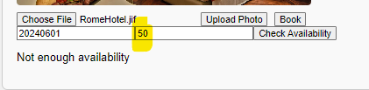

* Trying to book for 2 people, the 5th of June 2024

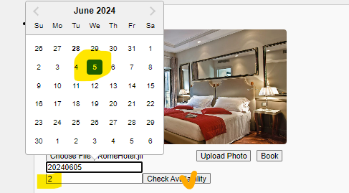

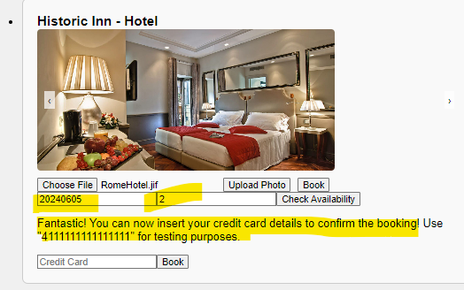

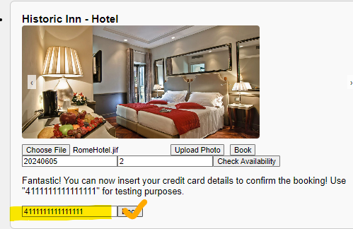

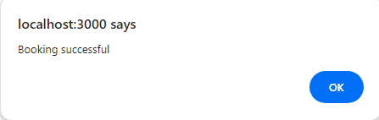

* In the console, a message is received to update the remaining availability on the 5th of June 2024

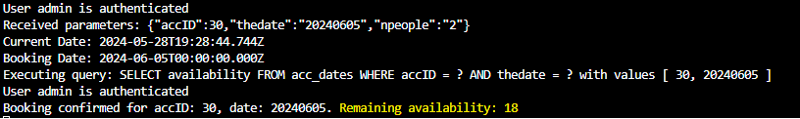

* The “view all” button in the map, allows the user to visualize all the accommodations available in this application. The user can then click on any marker and view name, description, or click the book button.

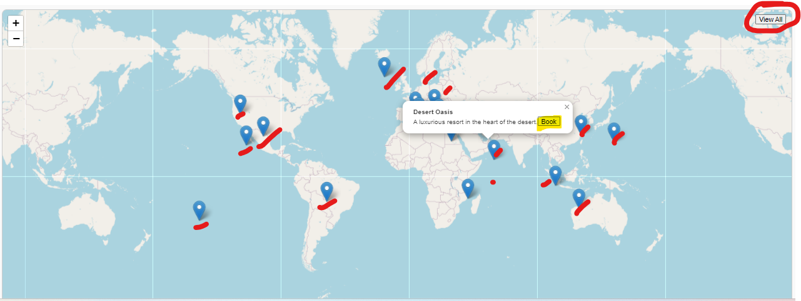

* If the user clicks on the book button, through the marker, the accommodation will be displayed fully on the left of the screen, ready to take details from the user's booking.

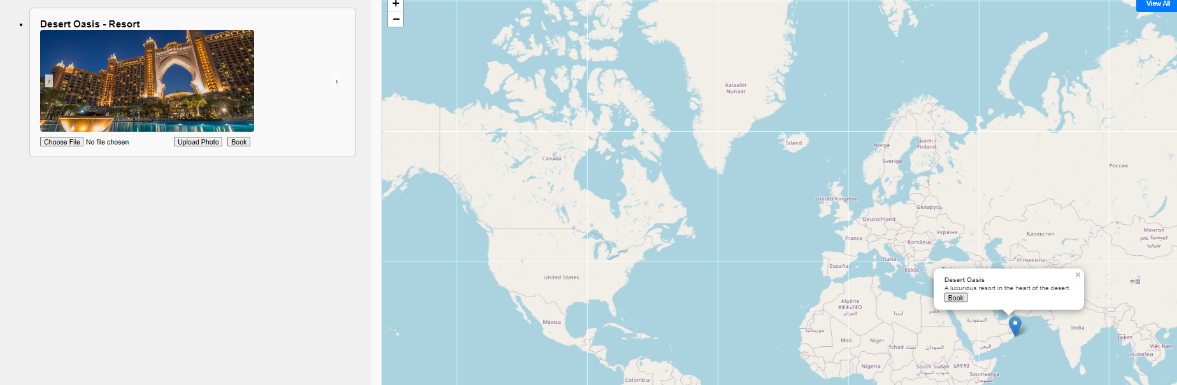

# GitHub and Deployment

# Running the project in a standard Node 14x environment using a Linux machine.

To ensure that the project “Place To Stay” can run in a Standard Node 14x environment on a Linux machine, considerations for Cross-Platform Compatibility have been addressed:

Dependencies: {all dependencies are specified in `package.json`

* server:

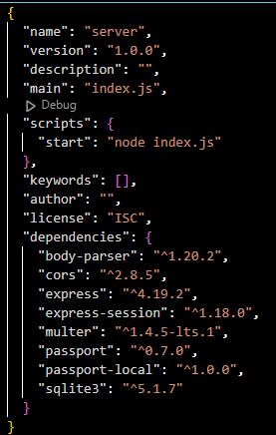

* client:

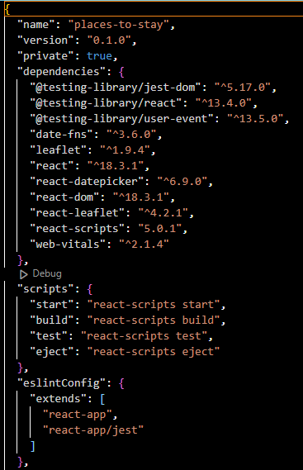

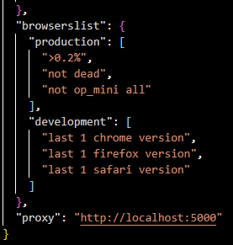

* Ensuring the project uses Node.js 14x





* Environment Variables:

The Environment Variables are loaded into the library “**dotenv”.**



In the main server, the environment variables are loaded.





# References

R. Thelin (2020) What is CORS [viewed on 20/04/24] available from [What is CORS (Cross-Origin Resource Sharing)? (educative.io)](https://www.educative.io/blog/getting-started-cors)

React-datepicker [viewed on 22/04/24] available from [react-datepicker - npm (npmjs.com)](https://www.npmjs.com/package/react-datepicker)